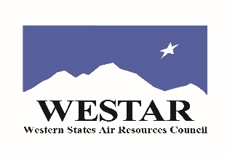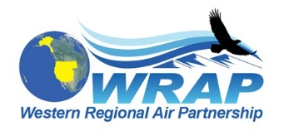
Tribal Data Work Group call - November 22, 2019

Summary of current/new action items – notes by E.R.

- Tom’s draft of outreach letter to tribes: Tom to incorporate Julie and Bill edits/comments; share next draft with TDWG.

- Contacts list: Emma will update, so send any needed changes you may see in the list to her. She will send to Tom by Dec 12 if no word from him or anyone before then. The new master list shouldn’t live on public website. List to be used for “1-time” participation letter to nonactive (never-active) tribes (goal is send by end of the year), responses will be added to the active members list for future WRAP correspondence. (An email may be sent around March for open board seats to active tribes) WRAP has some budget for continued ITEP work on list, ITEP not sure about that yet- maybe a biannual update is possible but it depends on methods used.

- EN3 august (13 pg) report on tribal oil & gas – Tom will share with WRAP OGWG & Ramboll; the report will then complete Task 1.4. Charlie- suggest to Tom even if it cannot be made a priority for overloaded OGWG, please call out an important point to Ramboll (?)

- Webinar debrief on next call date and time – Dec 12. Currently 17 registered.

- “Introducing” Lori- Lori informed Tribal Caucus at Fall meeting she would take on Kris’ role as Co-chair as well as fill a tribal board seat (as per Julie). Lori not on call so not able to confirm this to the group. She’s now being copied on TDWG correspondence with TSC. And these notes!

